US CRIME ANALYSIS

Create a SQL database containing data related to the case number, primary crime category, crime description, crime location, and arrest status using the dataset.
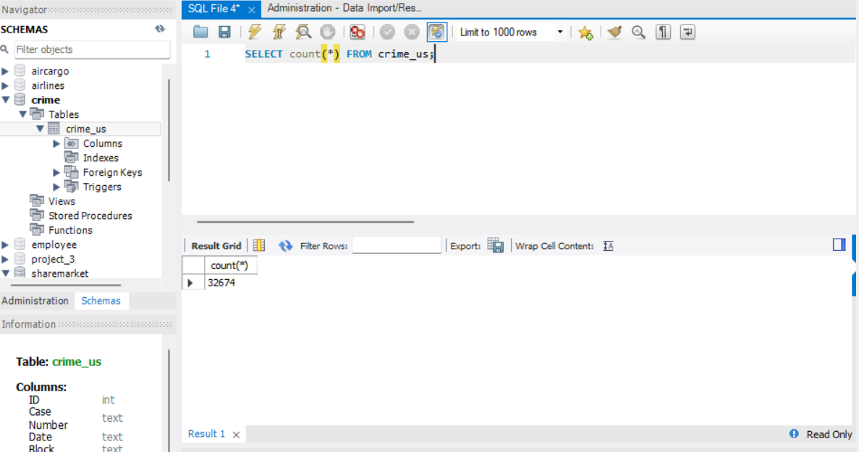

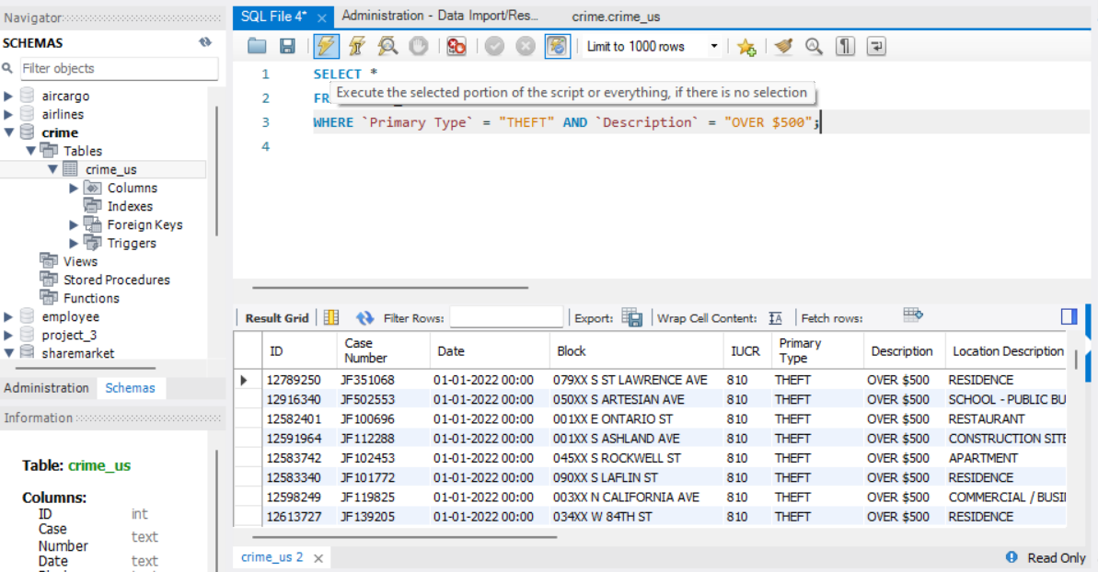

Make a database in SQL where theft costs more than $500.
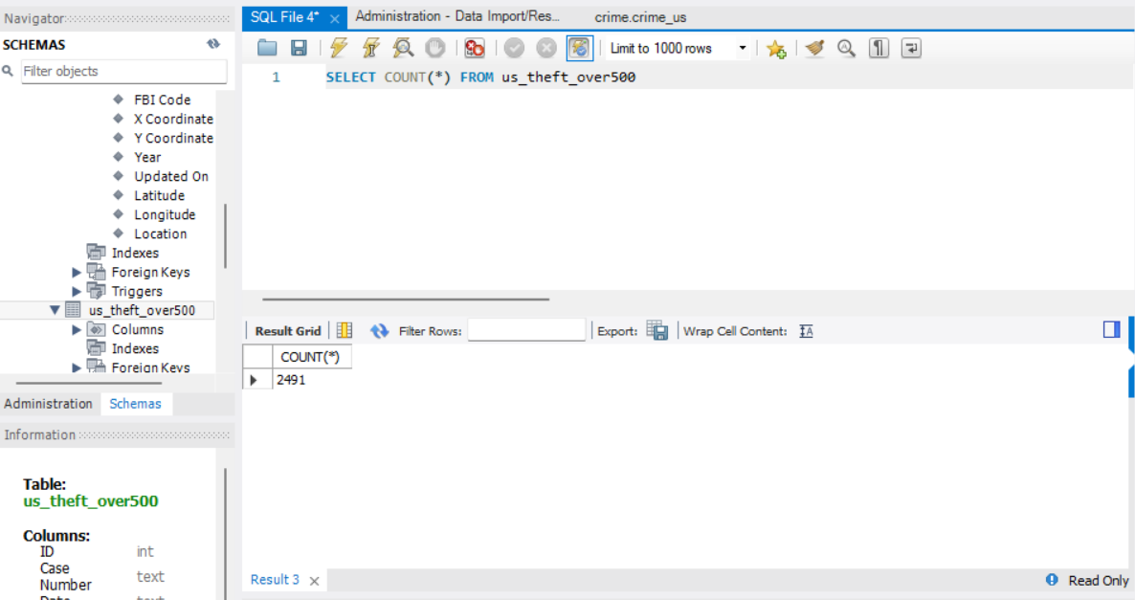

Determine the overall number of cases for each major category of crime.
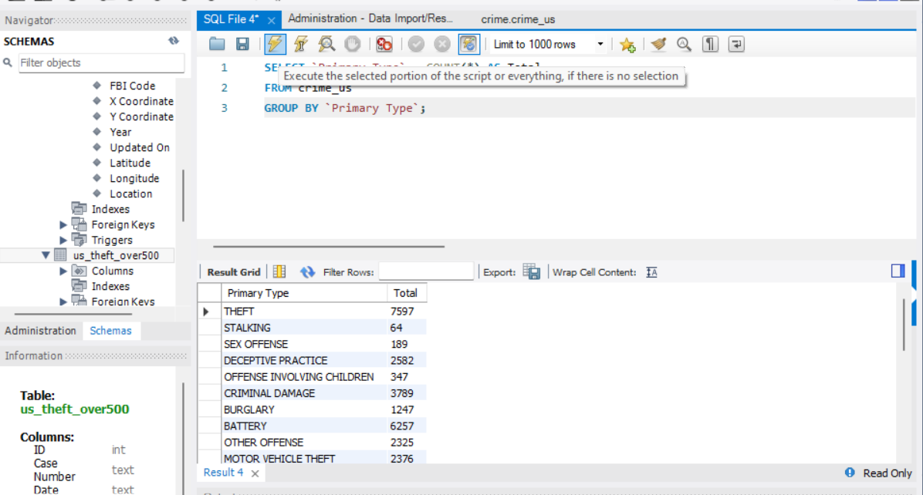

Apply 1NF normalization to the dataset provided.

